[Enter application name here]
UI Specification

Status | Draft/Proposal/Approved [choose document status]
Author | [Your name]
Approver | [Name of the approver]

TABLE OF CONTENTS

[UI specification name] Changes 3
Open issues 4
1 Introduction 5
1.1 Purpose of application 5
1.2 User task overview 5
1.3 UI state overview 5
1.4 Platform release and related features 6
1.5 Requirements and restrictions 6
1.6 Data descriptions 6
1.7 S60 UI components 7
2 User interaction 8
2.1 Writing the first use case 8
2.2 Writing the second use case 8
3 UI state description 9
3.1 Main view 9
3.1.1 Display description 9
3.1.2 Functional description 9
3.1.3 Options available 10
4 Feature interaction 11
5 Error cases 12
5.1 Errors caused by the user 12
5.1.1 [Title of the error situation] 12
5.2 Errors caused by the application 12
5.2.1 [Title of the error situation] 12
5.3 Errors caused by the S60 smartphone 12
5.3.1 [Title of the error situation] 12
5.4 Errors caused by network 12
5.4.1 [Title of the error situation] 12
5.5 Errors caused by accessories 12
5.5.1 [Title of the error situation] 12
References 13
Glossary 14
Appendix A 15
List of Logical Names 15
List of Icons 15

[UI specification name] Changes

Document version | Document status | Date | Editor | Changes
V1.1 | APPROVED | 27-Mar-2006 | [Edith Example] | [Editorial changes:  - corrected a typo in Chapter 3  - improved graphic 1.]
V1.0 | APPROVED | 15-Feb-2006 | [Edith Example] | [Review changes:  - Door locked notification edited to include a large graphic  - Instead of the “Locking wait note” a “Connecting to door progress note is displayed.”]
V0.5 | PROPOSAL | 1-Feb-2006 | [Edith Example] | [Added content:  - A new setting added: “Security code”  - A new icon added: “Door not secure”

Open issues
[The following issues related to application design are still open:
- Issue 1 – explanation of why this issue is still open
- Issue 2 – explanation of why this issue is still open
- Issue 3 – explanation of why this issue is still open]

Introduction
[Insert text here]

[What is the purpose of this document?
Who are the target readers of this document?]

Purpose of application
[Insert text here]

[What can the application be used for? / What can the user do with this application?
What are the most important features of the application?
Who are the end users of this application?
What is the end user need that this application fulfills?
What are the main benefits of this application?
What are the operator benefits (if any)?]

User task overview
[Insert text here]

[With the XXX application, the user is able to:
- Perform task 1, see Chapter 2.1 “Writing the first use case”
- Perform task 2, see Chapter 2.2 “Writing the second use case”]

UI state overview
[Insert text here]

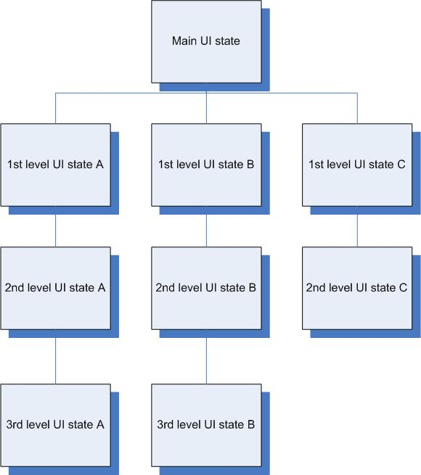

Figure x. UI state overview

Platform release and related features
[Name of the application] is intended for the following S60 platform releases: […]

[Name of the application] requires the following features: [feature 1], [feature 2], and [feature 3]

Requirements and restrictions
[Example:
- [Name of application] requires that the S60 smartphone has either a built-in GPS chip or a compatible GPS accessory.
- [Name of application] requires the API for messaging
- This application requires X amount of ROM and X amount of RAM ]

Data descriptions
[Insert text here]

Data | Data type displayed to the user (Y/N) | Value range | Default value | Notes

Table x. Data descriptions

S60 UI components
[Example: Application XXX utilizes the following S60 UI components:
- Selection grid
- Confirmation note
- List query]

User interaction
[Insert text here]

Writing the first use case
[Insert text here]

Title
Preconditions
Trigger
Step sequence | - Step 1  - Step 2  - Step 3
Extensions
Exceptions
Postconditions

Table x. [Title of the use case]

Writing the second use case

[Insert text here]

Title
Preconditions
Trigger
Step sequence | Step 1  Step 2  Step 3
Extensions
Exceptions
Postconditions

Table x. [Title of the use case]

UI state description

[Insert text here]

Main view

[Insert text here]

Display description

[Insert text here]

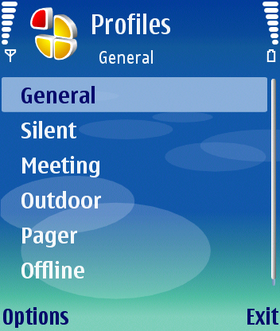

Figure X. View XX

Standard Panes | Subpane | Content displayed
Status Pane
 | Signal pane
 | Context pane
 | Title pane
 | Navi pane
 | Battery pane / Universal indicator pane
Main Pane
Scroll Pane
Control Pane

Table x. Pane descriptions

Functional description

[Insert text here]

Key type | Key | Effect
Navigation keys
 | Selection key | [Define effect here]
 | Arrow up | [Define effect here]
 | Arrow down | [Define effect here]
 | Arrow right | [Define effect here]
 | Arrow left | [Define effect here]
Softkeys
 | Left softkey | [Define effect here]
 | Right softkey | [Define effect here]
Call handling keys
 | Call creation key | [Define effect here]
 | Call termination key | [Define effect here]
Other keys
 | Applications key | [Define effect here]
 | Clear key | [Define effect here]
 | Edit key | [Define effect here]
 | Alphanumeric keypad, with ITU-T numeric keypad (0-9, *, #) as default. | [Define at least exceptional effects here]
 | Power key | [Define effect here]
Extra keys
 | Camera key | [Define effect here]
 | Voice key | [Define effect here]
 | Volume keys | [Define effect here]

Table x. Key events

Note: If your application supports S60 smartphones with a full QWERTY keyboard, another separate table is needed for the QWERTY keys.

Options available
[Insert text here]

Option | Description
Option item 1 | [Define effect here]
Option item 2 | [Define effect here]

Table x. Options available

Feature interaction
[Insert text here]

Title
Preconditions
Trigger
Step sequence | - Step 1  - Step 2  - Step 3
Extensions
Exceptions
Postconditions

Table x. [Title of the use case]

Error cases

Errors caused by the user
[Insert text here]

[Title of the error situation]
[Insert text here]

Errors caused by the application
[Insert text here]

[Title of the error situation]

Errors caused by the S60 smartphone
[Insert text here]

[Title of the error situation]

Errors caused by network
[Insert text here]

[Title of the error situation]

Errors caused by accessories
[Insert text here]

[Title of the error situation]

References

Glossary

[Insert text here]

Term | Explanation

Table x. Terms and definitions

Appendix A

List of Logical Names

List of Icons

